**PRACTICAL -6**

**Aim** - **TO IMPLEMENT NESTED QUERIES**

CREATE table employee (eno., ename , addr, salary , deptno.)

Insert 5 rows any two employee may have same deptno. and answer the following queries:

1. select ename , eno, addr from employee where salary > (select salary from employee where ename = 'jones')

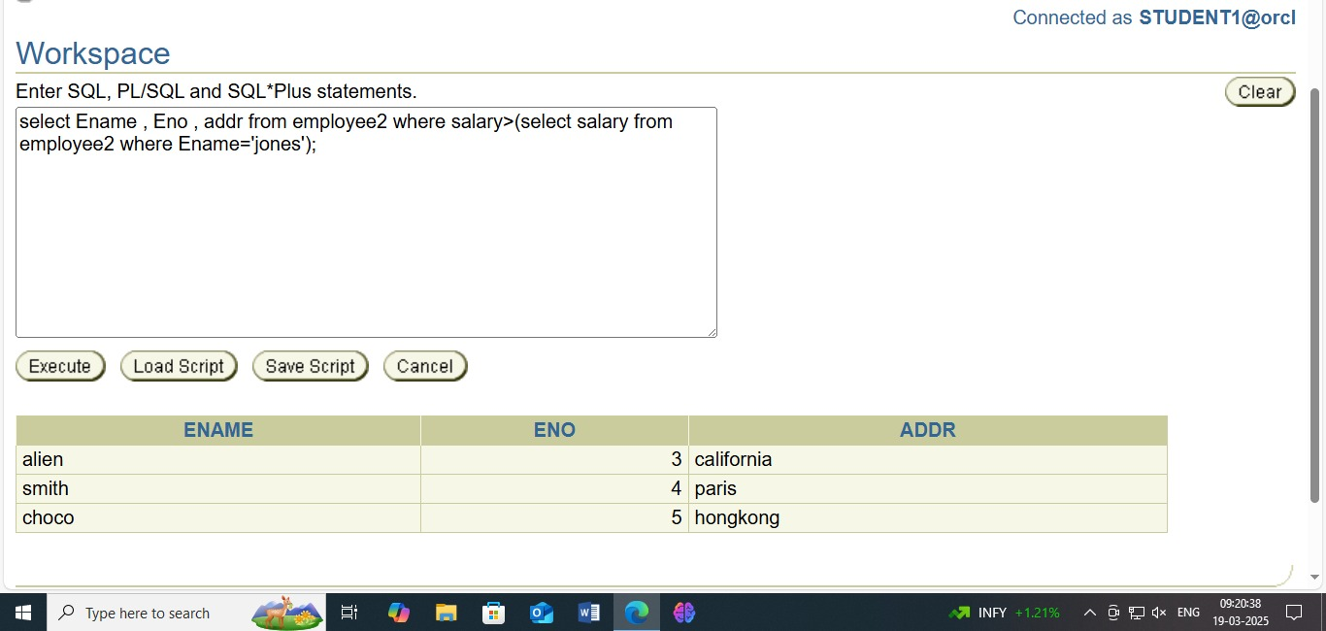

1. select ename , eno,from employee where salar < any(select salary from employee where deptno. = '10')

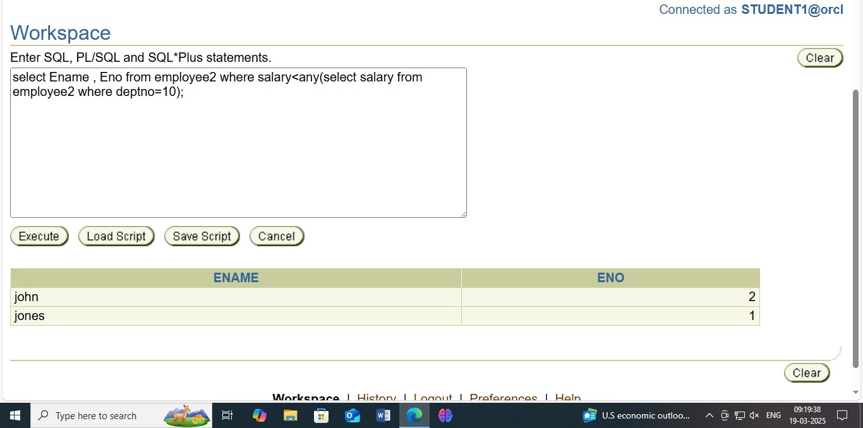

1. select * from employee x where x.salary > (select avg (salary ) from employee where dept no. = x.deptno.)

